DSA0601- DATA HANDLING AND VISUALIZATION
EXPERIMENTS 6 – 10
DSA0601- DATA HANDLING AND VISUALIZATION


Product Sales Analysis
Product Sales Analysis
EXPERIMENT 6
R.S.POOJASHRI (1G2324266)
M.Yogesh (192324283)
EXPERIMENT 6

Dataset: Monthly Product Sales

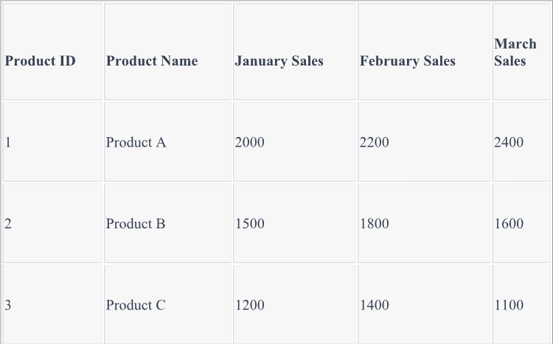
CODE:
# Dataset
product <- data.frame(
Product = c("Product A","Product B","Product C"), January = c(2000,1500,1200),
February = c(2200,1800,1400), March = c(2400,1600,1100)
)
# 1. Grouped Bar Chart
sales <- as.matrix(product[,2:4]) barplot(sales,
beside=TRUE,
col=c("red","blue","green"),

names.arg=product$Product, xlab="Products",
ylab="Sales",
main="Quarter 1 Product Sales") legend("topright",
legend=c("January","February","March"), fill=c("red","blue","green"))
# 2. Stacked Area Chart months <- c(1,2,3)
matplot(months, t(sales), type="l",
lwd=2,
col=c("red","blue","green"), xaxt="n",
xlab="Months", ylab="Sales", main="Sales Trend")
axis(1, at=1:3,
labels=c("January","February","March")) legend("topleft",
legend=product$Product, col=c("red","blue","green"), lty=1)
# 3. Table Product QUESTIONS:
- Create a grouped bar chart to visualize the sales of each product for the first quarter. Label the chart elements.

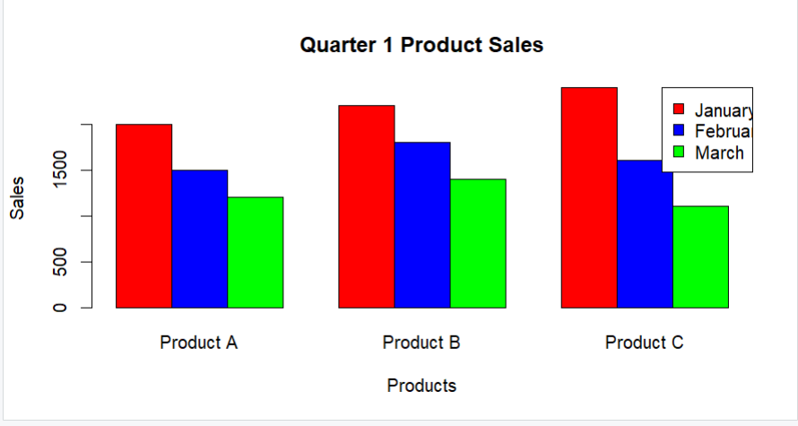
- Generate a stacked area chart to represent the overall sales trend for all products over the three months.

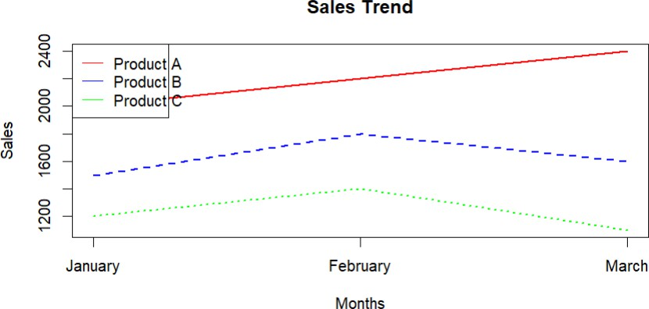

- Build a table to show the monthly sales data for each product. Label the table elements.
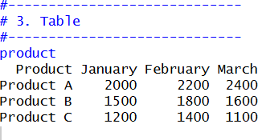

EXPERIMENT 7

Customer Demographics Analysis
Dataset: Customer Demographics
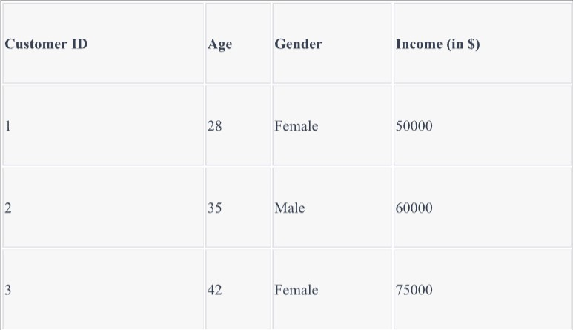

CODE:
# Customer Demographics customer <- data.frame(
CustomerID=c(1,2,3), Age=c(28,35,42),
Gender=c("Female","Male","Female"), Income=c(50000,60000,75000)
)
# 1. Age Distribution Bar Chart barplot(customer$Age,
names.arg=customer$CustomerID, col="skyblue",
xlab="Customer ID", ylab="Age",
main="Customer Age Distribution") # 2. Gender Pie Chart
gender_count <- table(customer$Gender)

pie(gender_count, col=c("pink","lightblue"),
main="Gender Distribution") # 3. Table
Customer

QUESTIONS
- Create a bar chart to visualize the distribution of customer ages. Label the axes and title the chart.
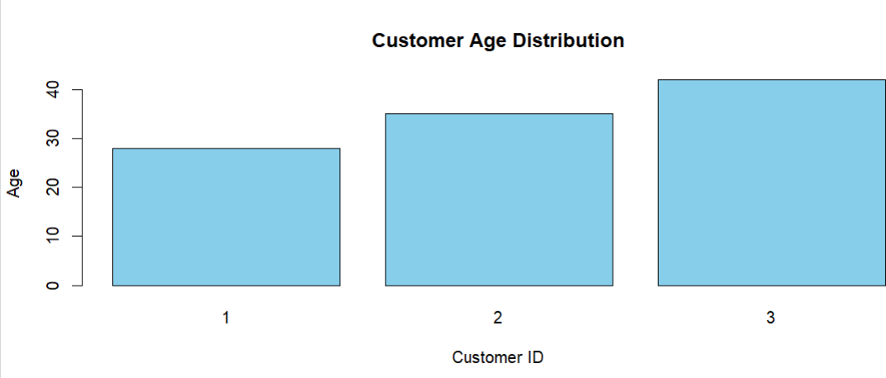
- Generate a pie chart to represent the distribution of customers by gender.

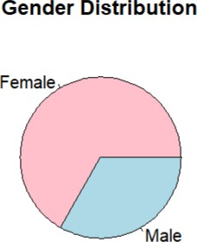

- Build a table to show the demographic information for each customer. Label the table elements.
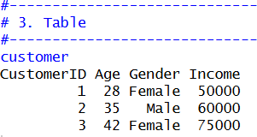

EXPERIMENT 8

Employee Performance Analysis
Dataset: Employee Performance
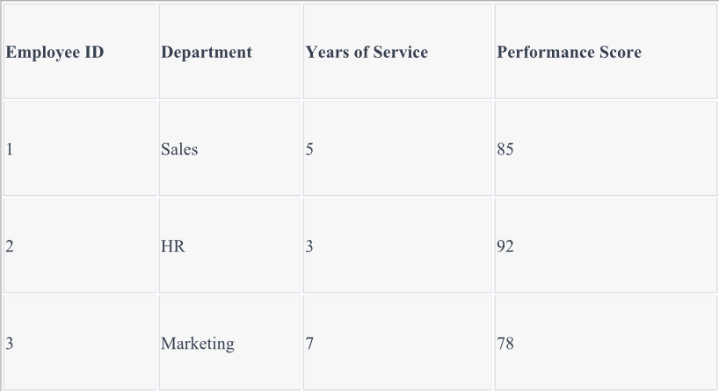

CODE:
# Employee Performance employee <- data.frame( EmployeeID=c(1,2,3),
Department=c("Sales","HR","Marketing"), Years=c(5,3,7),
Performance=c(85,92,78)
)
# 1. Line Chart
plot(employee$Years,
employee$Performance, type="o",
pch=16, col="blue",
xlab="Years of Service", ylab="Performance Score", main="Employee Performance Trend")
# 2. Department Bar Chart

dept <- table(employee$Department) barplot(dept,
col="orange", xlab="Department", ylab="Number of Employees",
main="Employees by Department") # 3. Table
Employee

QUESTIONS:
- Create a line chart to visualize the performance trend of employees over time. Label the axes and title the chart.
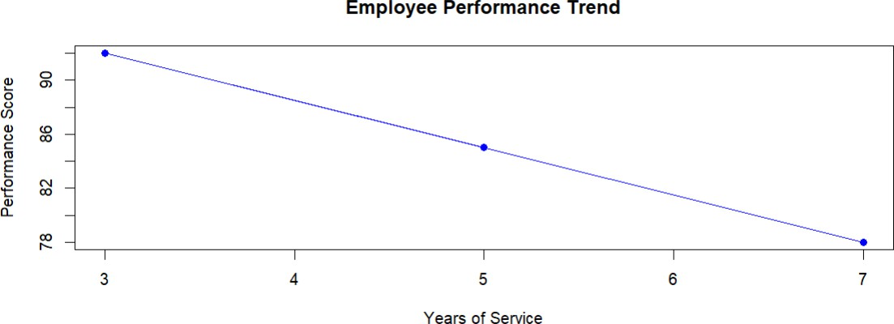

- Generate a bar chart showing the distribution of employees across different departments.
Label the chart elements.

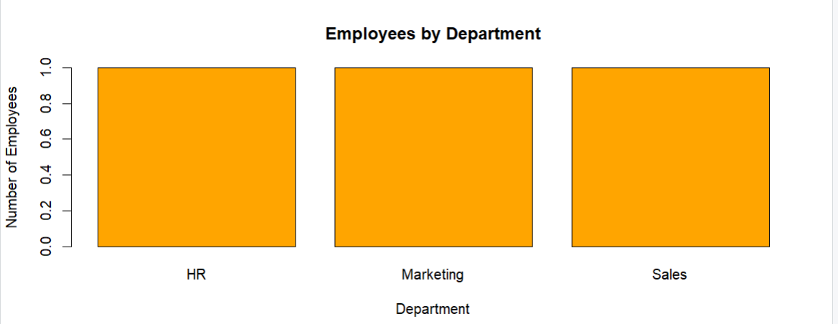
- Build a table to display the performance data for each employee. Label the table elements.
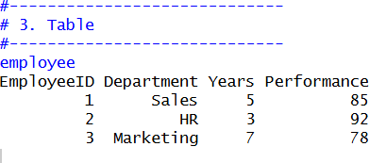

EXPERIMENT G

Product Inventory Management
Dataset: Product Inventory

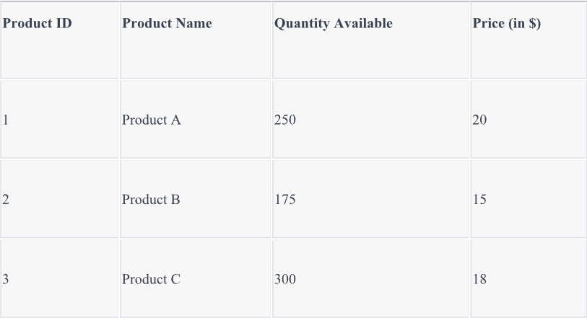

CODE
# Product Inventory inventory <- data.frame(
Product=c("Product A","Product B","Product C"), Quantity=c(250,175,300),
Price=c(20,15,18)
)
# 1. Quantity Bar Chart barplot(inventory$Quantity,
names.arg=inventory$Product, col="green",
xlab="Products", ylab="Quantity", main="Inventory Quantity")
# 2. Stacked Bar Chart
data <- rbind(inventory$Quantity, inventory$Price)
barplot(data,

col=c("blue","red"),
names.arg=inventory$Product, xlab="Products",
ylab="Values",
main="Quantity and Price") legend("topright",
legend=c("Quantity","Price"), fill=c("blue","red"))
# 3. Table Inventory QUESTIONS:
- Create a bar chart to visualize the quantity of each product in the inventory. Label the axes and title the chart.
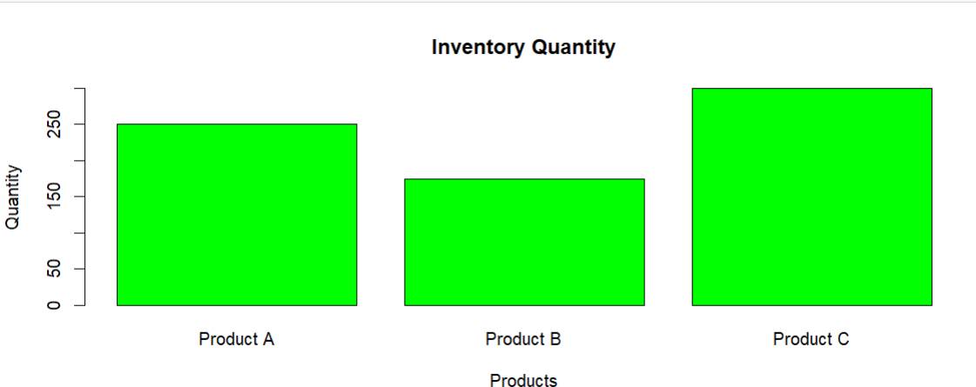

- Generate a stacked bar chart to show the quantity of each product within different product categories.

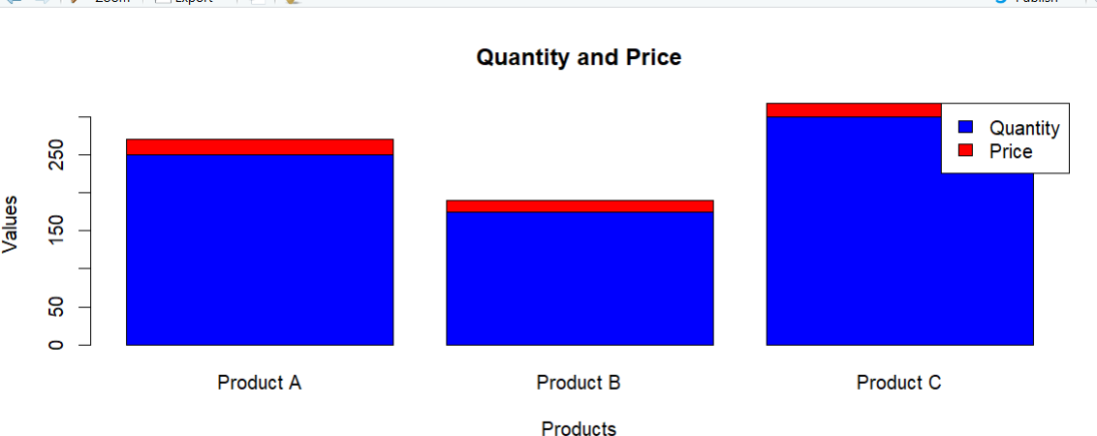

- Build a table to show the inventory data for each product. Label the table elements.
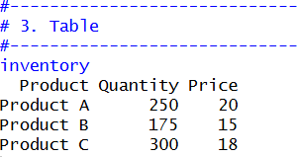

EXPERIMENT 10

Survey Responses Analysis
Dataset: Survey Responses
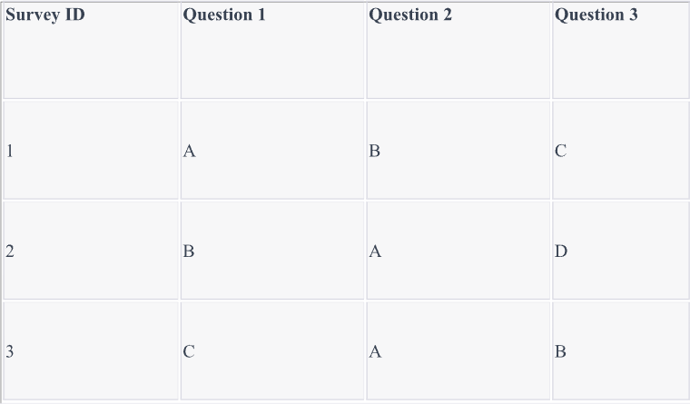

CODE:
# Survey Responses survey <- data.frame( SurveyID=c(1,2,3), Q1=c("A","B","C"),

Q2=c("B","A","A"),
Q3=c("C","D","B")
)
# 1. Grouped Bar Chart (Q1) q1 <- table(survey$Q1) barplot(q1,
col=c("red","blue","green"), xlab="Responses", ylab="Frequency",
main="Question 1 Responses") # 2. Stacked Bar Chart
responses <- rbind(
table(factor(survey$Q1, levels=c("A","B","C","D"))),
table(factor(survey$Q2, levels=c("A","B","C","D"))),
table(factor(survey$Q3, levels=c("A","B","C","D")))
)
barplot(t(responses), beside=FALSE,
col=c("red","blue","green"), xlab="Responses", ylab="Count",
main="Survey Responses") legend("topright",
legend=c("Question1","Question2","Question3"), fill=c("red","blue","green"))
# 3. Table survey QUESTIONS:

- Create a grouped bar chart to visualize the distribution of answers for Question 1. Label the chart elements.
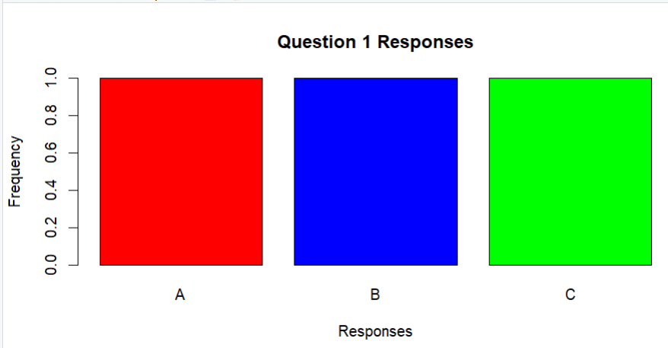
- Generate a stacked bar chart to represent the overall distribution of responses for all three questions.
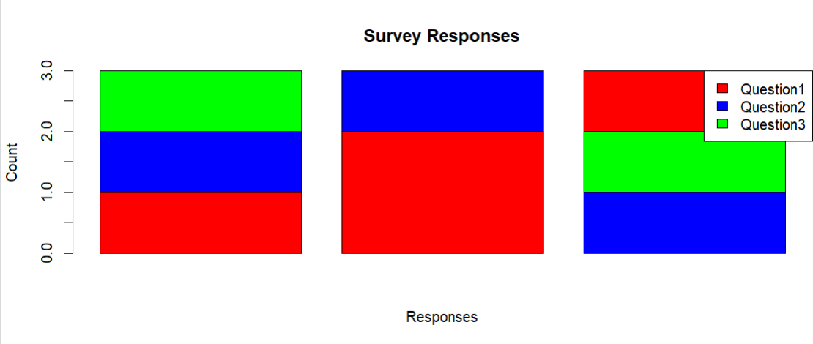
- Build a table to show the survey response data for each survey. Label the table elements.
